Virtualization Lab Assignment

BIA 4650 — University of Idaho, College of Business & Economics

# Step-by-Step Tasks

1. **Install VirtualBox**

1. **Create VM & Attach ISO [Screenshot #2]**

Create a new VM named FirstnameInitialLastnameInitial VM. Attach the correct Ubuntu Server ISO (AMD64 for Intel/Windows, ARM64 for Apple Silicon).

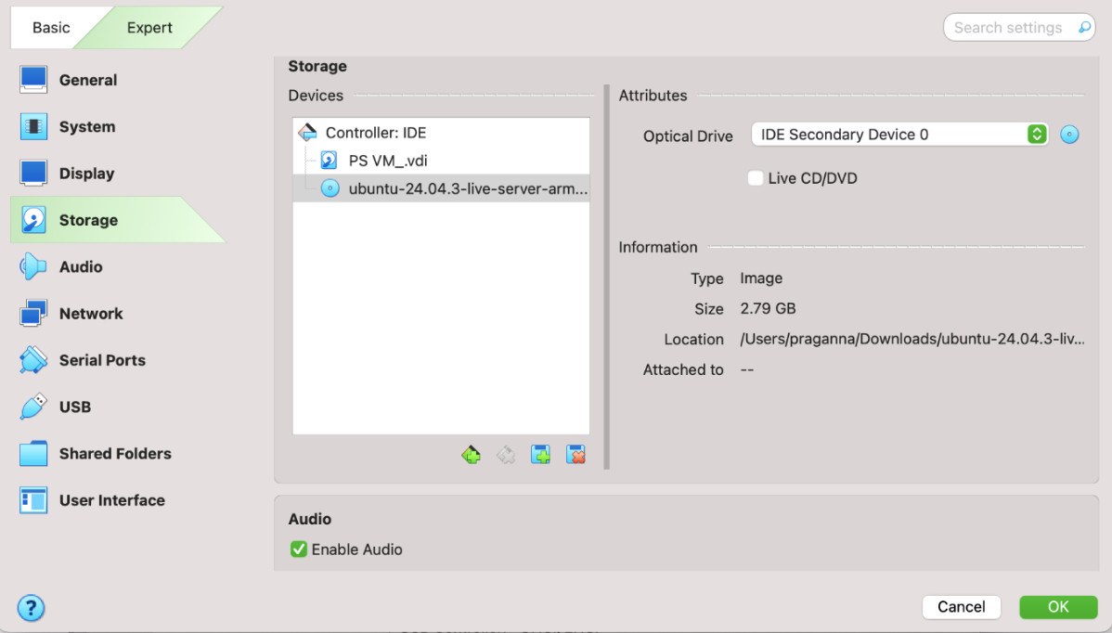

1. **Allocate Resources [Screenshot #3]**

**Rule of Thumb:** Do not allocate more than 50% of your laptop’s RAM or CPU cores. Recommended: Base memory = 2–4 GB, vCPU = 4 (or ≤ 50% of cores), Disk = 25 GB

(dynamic). Take a screenshot of the VM settings (Memory, Processors, and Storage).

1. **Boot VM & Create Login**

Start the VM, follow Ubuntu’s guided installation, and create a username/password. Log in after reboot to access the shell.

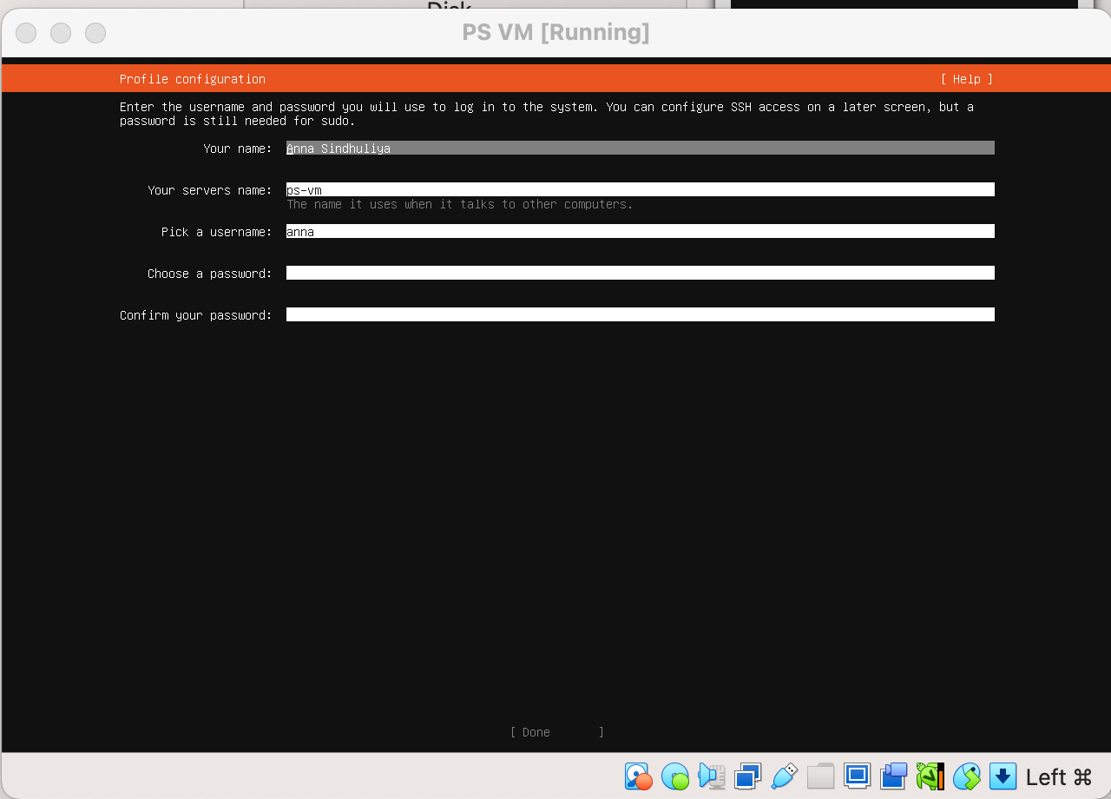

1. **Verify VM Resources [Screenshot #4]**

Run all three commands in a single session and take one screenshot showing outputs:

|  |  |
| --- | --- |
| free -h | # shows memory available |
| nproc | # shows number of vCPUs |
| df -h / | # shows disk usage/size |
|  |  |

1. **Create a Test File [Screenshot #5]**

Inside the VM, create a file and verify it exists:

nano test_file

# type a sentence, save (Ctrl+O, Enter), exit (Ctrl+X) ls -l

Take a screenshot showing test file in the directory.

1. **Take a Snapshot [Screenshot #6]**

Open the *Snapshots* tab in VirtualBox and take a snapshot named Before deleting test file. Take a screenshot showing the snapshot listed.

1. **Test Snapshot Restore [Screenshots #7 and #8]**

# Reflection Questions (3–6 sentences each)

**Q1.** In business terms, how does a snapshot reduce risk and cost during software updates or testing?

A snapshot is like a safety net. If an update or test messes something up, you can roll back to the exact state before the change. This saves time because you don’t have to rebuild or troubleshoot from scratch. It also saves money since the system can get back up quickly without long downtime.

**Q2.** How do resource limits (RAM/CPU) help balance performance and cost in a shared computing environment?

When multiple users or systems share the same hardware, setting limits makes sure no one hogs all the resources. It keeps everything running smoothly and fair for everyone. It also prevents companies from overspending on hardware or cloud resources they don’t actually need. Basically, it’s about finding a balance between performance and cost.

**Q3.** Give one business scenario (e.g., online store during Black Friday) where restoring a snapshot could save time and money.

Imagine an online store during Black Friday. If they push out a new update to the checkout system and it breaks, customers can’t buy anything. With a snapshot, the store can roll back right away and keep sales going. Without it, they’d lose money and frustrate a lot of customers.

**Q4.** Contrast *saving a file* vs. *taking a snapshot*. What does each preserve, and when would you use one over the other?

Saving a file just keeps one document or piece of work safe, like a Word file or report. A snapshot is bigger, it saves the entire system state, including files, programs, and settings. I’d save a file for normal work, but I’d take a snapshot before a big system changes in case something goes wrong.